Eric Tuan
1 November 2006
AP Biology
Period 3
The Effect of Light Conditions and Boiling on the Rate of Photosynthesis by Isolated Chloroplasts

Abstract:

The light-dependent reactions of photosynthesis split water to obtain high energy electrons, which are passed to an electron acceptor called NADP+ to be utilized to produce a three-carbon sugar in the Calvin cycle. (Campbell et. al, 2005) When observing photosynthesis in isolated chloroplasts, DPIP can be used as an indicator – when reduced by the addition of electrons, DPIP turns from a dark blue color to clear, allowing a greater percentage of light to pass through (Hickey, 2000) The purpose of the experiment was to observe the effects of light/dark conditions and boiling on the percentage of light transmission through various chloroplast samples, and thus measure the effects of the same conditions on the rate of photosynthesis. The clearest trend in the results was that over the total time period of fifteen minutes, the mixture of unboiled chloroplasts placed in the light consistently allowed the transmittance of the most light – the trendline for the unboiled/chloroplast mixture when time was graphed against the percentage of light transmitted had a slope 89.8% steeper than any of the other trendlines. None of the other samples (unboiled/dark, boiled/light, and no chloroplasts) demonstrated any significant change in the percentage of light transmission – the greatest deviation from the mean over time for the other three samples was 6.85%, contrasted with a deviation of 31.3% for the unboiled/light chloroplast samples. From these data, the scientists concluded that, after being tested as independent variables in a controlled experiment, lack of light and boiling of the chloroplasts prevented the chloroplasts from carrying out the light-dependent reactions of photosynthesis, to produce high-energy electrons and reduce DPIP. The scientists concluded that light and live, non-boiled chloroplasts are required to run the light-dependent reactions of photosynthesis

Results:

The Effect of Time on Percentages of Light Transmission in Varied Chloroplast Samples (Period 3)

Time (in minutes) | Unboiled/Dark Chloroplasts (in %) | Unboiled/Light Chloroplasts (in %) | Boiled/Light Chloroplasts (in %) | No Chloroplasts (in %)
0 | 22.3 | 29.3 | 24.3 | 27
5 | 35.8 | 50.7 | 25.1 | 26.8
10 | 29.5 | 68.5 | 23.4 | 24.4
15 | 30.8 | 69.6 | 17 | 17.3

The Effect of Time on Percentages of Light Transmission in Varied Chloroplast Samples (Period 4)

Time (in minutes) | Unboiled/Dark Chloroplasts (in %) | Unboiled/Light Chloroplasts (in %) | Boiled/Light Chloroplasts (in %) | No Chloroplasts (in %)
0 | 28.6 | 26.5 | 27.8 | 26.5
5 | 31.2 | 52.4 | 28.1 | 26.7
10 | 32.9 | 68.8 | 23.2 | 35.7
15 | 34.4 | 83.4 | 27.7 | 26.5

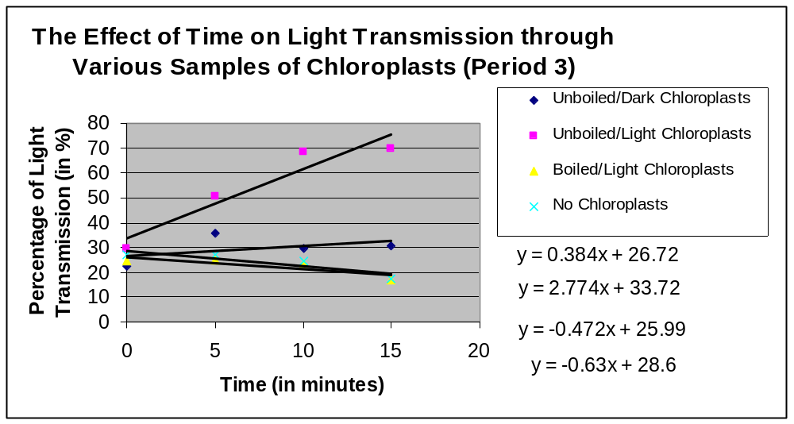

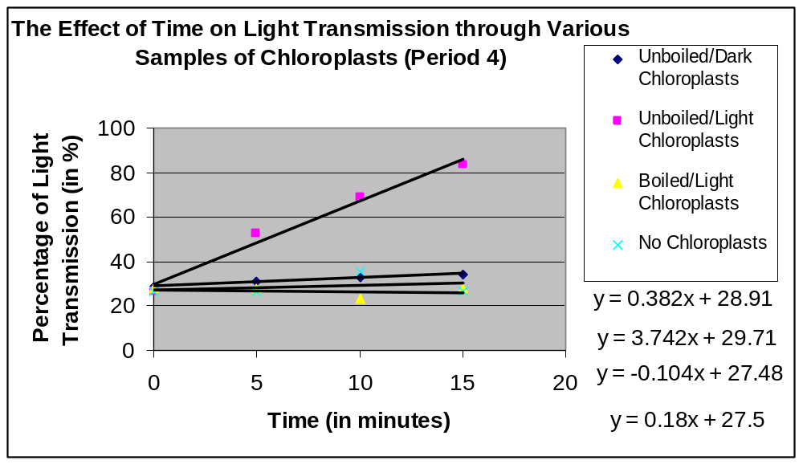

Trend Paragraph:

The most prevalent trend in the data was that over the total time period of fifteen minutes, the mixture of unboiled chloroplasts placed in the light consistently allowed the transmittance of the most light. For example, after fifteen minutes, the mixture of unboiled chloroplasts left in the light allowed the transmittance of 83.4% of light, while the other three mixtures only allowed the average transmittance of 29.5% of light. The trend is shown most dramatically in the slope of the trendline for the graphs – for example, on the graph of light transmission for Period 4, the slope is 89.8% greater for the unboiled/light chloroplasts than for any other chloroplast mixture. Although the mixture of unboiled chloroplasts left in the light showed the greatest increase in percentage of transmission of light over time, the other chloroplast mixtures generally did not change their percentage of light transmission over time. For example, over fifteen minutes the greatest deviation from the mean light transmission of the unboiled/dark chloroplasts was 3.18%; the greatest deviation from the mean of the boiled/light chloroplast sample was 3.50%; and the greatest deviation from the mean of the sample containing no chloroplasts was 6.85%. These statistics compare with a maximum deviation of 31.3% from the mean of the light transmission for the unboiled/light chloroplast sample. In general, over the passage of time, the sample of unboiled/light chloroplast allowed an increasingly greater percentage of light transmission, while the other samples of chloroplasts only allowed a very similar or nearly identical percentage of light transmission.

R_{f} Values (distance pigment migrated/distance solvent front migrated)(in mm)

Period 3 | Table 3 | Table 4 | Table 5 | Table 7 | Mean
Green | 0.11 | 0.07 | 0.06 | 0.09 | 0.09
Yellow | 0.24 | 0.14 | 0.08 | 0.23 | 0.23
Green | 0.19 | 0.22 | 0.17 | 0.15 | 0.15
Yellow | 1.0 | 1.0 | 1.0 | 1.0 | 1.0

R_{f} Values (distance pigment migrated/distance solvent front migrated)(in mm)

Period 4 | Table 2 | Table 4 | Table 6 | Table 7 | Mean
Green | 0.05 | 0.04 | 0.08 | 0.09 | 0.07
Yellow | 0.14 | 0.07 | 0.15 | 0.12 | 0.12
Green | 0.18 | 0.2 | 0.19 | 0.2 | 0.19
Yellow | 1.0 | 1.0 | 1.0 | 1.0 | 1.0

Discussion/Conclusion:

In this experiment, the DPIP functions as an indicator of whether photosynthesis is occurring in the isolated chloroplast samples. DPIP is blue when in its oxidized state, not allowing light to pass through; however, when DPIP is reduced by the addition of electrons, the DPIP turns from a blue to a colorless solution. The reduction of DPIP can thus be measured by the percentage of light transmitted through the solution – as DPIP is continuously reduced by the addition of electrons, the substance becomes more clear and transmits more light. (Hickey, 2000) In this fashion, DPIP replaces the NADP+ molecules in the chloroplast cell, which are reduced to NADPH by the electron transport chain at the end of PS I. DPIP functions as an electron acceptor, accepting the high-energy electrons from the light-dependent reactions and using their energy to run the Calvin cycle. (Campbell et. al, 2005)
The most common and clear trend in the data was that over the total time period of fifteen minutes, the mixture of unboiled chloroplasts placed in the light consistently allowed the transmittance of the most light. This trend is demonstrated dramatically in the slopes of the trendlines for the different samples of chloroplasts where time is graphed against the percentage of light transmitted – for example, on the graph of light transmission for Period 4, the slope is 89.8% greater for the unboiled/light chloroplasts than for any other chloroplast mixture. Since the percentage of light transmitted increased so dramatically over time, the scientists conclude that the DPIP was reduced (causing the solution to turn clear) by the addition of electrons produced by the light-dependent reactions of photosynthesis.
The lack of light dramatically affects the reduction of DPIP because without light, the chloroplasts cannot run the light-dependent reactions and no electrons are produced to reduce DPIP. This trend is demonstrated in the data – the unboiled chloroplasts left in the dark only increased their percentage of light transmission by 8.5% over fifteen minutes, while the unboiled chloroplasts left in the light increased their percentage of light transmission by 56.9%. The similar data from both classes lead to the conclusion that the lack of light prevents the chloroplasts from carrying out the light-dependent reactions and producing electrons to reduce DPIP. The boiling of the chloroplasts also prevented the reduction of DPIP – samples of boiled chloroplasts continually produced a flat or negative trend line. For example, the slope of the trend line for the sample of boiled/light chloroplasts is a meager -0.104. Based on agreeing data from both classes, the scientists conclude that boiling the chloroplasts prevents them from carrying out the light-dependent reactions and subsequent reduction of DPIP.
The data in this experiment was generally very accurate, demonstrating clear trends that agreed with the function of DPIP as an oxidizing agent, replacing NADP+ in photosynthesis. The scientists were accurately able to use the spectrophotometers to observe the varying amounts of light transmission between different chloroplast samples. However, one of the spectrophotometers lacked a zero knob, and as a result, the data from the scientists using the spectrophotometer was dramatically lower (in terms of light transmission) than the data from the rest of the class. Although the data demonstrated the same general trends of the class, for the purposes of maintaining an accurate class mean, the scientists omitted the data from the class means in the experiment.

References:

Campbell, N. and Reece, Jane B. (2005) Biology, 7th Edition. (189-195)

Hickey, Mary Kay. Photosynthesis and Spectrophotometry. Retrieved November 1, 2006 from Cornell Institute for Biology Teachers.
Website: http://cibt.bio.cornell.edu/labs/phys/PHO_0004.PDF

